Efficiency and Accuracy of Few-Shot Learning Frameworks

Abstract
This document presents a pure performance comparison of various Few-Shot Learning (FSL) frameworks applied to hyperspectral crop signature classification. The objective is to evaluate the efficiency and accuracy of different combinations of FSL frameworks and backbone architectures.
Frameworks Evaluated
The evaluation was conducted across three FSL frameworks:
- Prototypical Networks (ProtoNet): Metric-based FSL representing classes by average embeddings.
- Relation Networks (RelationNet): Metric-based FSL learning a non-linear similarity metric.
- Model-Agnostic Meta-Learning (MAML): Optimization-based FSL for fast adaptation.
Accuracy Comparison
1 ) RelationNet
The RelationNet architectures achieved consistently high accuracies across trials.
CNN+Attention and CNN+Mamba both improved the model performance compared to the basic CNN setup. CNN+Mamba especially showed strong stability and high median accuracy.
The combined CNN+Attention+Mamba version achieved the best overall performance, showing that integrating
multiple feature-learning mechanisms improved the relational learning capability of RelationNet.
Loss Curve
All RelationNet models reduced loss steadily during training. However, CNN+Mamba and CNN+Attention+Mamba reduced loss faster and more smoothly than the others.
This suggests that Mamba likely helped capture broader contextual dependencies while Attention enhanced important feature selection.
Accuracy Curve
The accuracy curves show that all models improved over time, but the hybrid models improved faster and achieved higher final accuracies.
Even though the CNN+Mamba and CNN+Attention+Mamba models began with slightly lower accuracy initially, they quickly caught up and eventually outperformed the basic CNN model. Toward the end of training, their accuracies stabilized near 100%, indicating excellent learning and generalization performance.
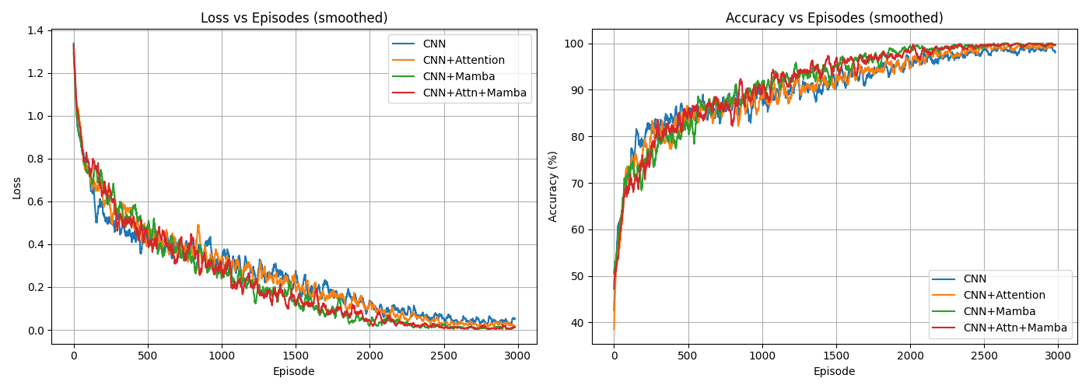
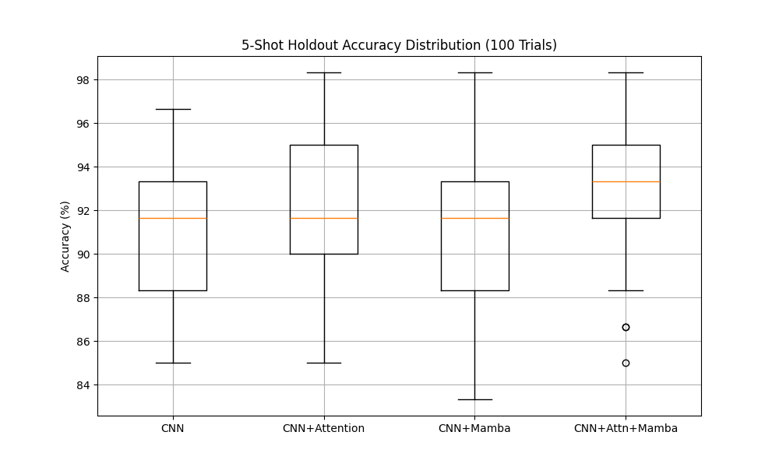

2 ) ProtoNet
This graph shows the average holdout accuracy over 100 trials for different ProtoNet architectures.
The basic CNN model achieved around 90.67%, showing decent performance but with noticeable variability. Adding Attention improved the accuracy to 92.28%, meaning the model became better at focusing on important regions and features in the data.
CNN+Mamba achieved 91.23%, showing that Mamba improved sequence and contextual understanding. The best performance came from the combined CNN+Attention+Mamba model with 92.77% accuracy.
Even though some models started with lower accuracies initially, they improved steadily during training and became more stable toward the end. The combined architecture benefited from both attention-based feature selection and Mamba-based sequence learning, leading to stronger generalization.
Loss vs Episodes
The CNN-only model reduced loss slowly and had more fluctuations, indicating slower learning and less stable optimization. CNN+Attention initially reduced the loss quickly, but later showed some instability before improving again.
CNN+Mamba reduced the loss much faster after the early episodes, showing efficient learning capability. The CNN+Attention+Mamba model had one of the smoothest and fastest reductions in loss, eventually reaching the lowest loss values.
This indicates that combining Attention and Mamba helped the model converge faster and learn more meaningful representations.
Accuracy vs Episodes
The CNN model improved gradually but saturated below the hybrid models. CNN+Attention started strong and improved steadily. CNN+Mamba had a slower beginning, but after several episodes its accuracy increased rapidly and eventually approached nearly 100% accuracy.
The CNN+Attention+Mamba model performed best overall. Even though its initial accuracy was moderate, it improved consistently and reached high training accuracy approaching saturation toward the end of training. This demonstrates that the hybrid architecture learned more effectively as training progressed.
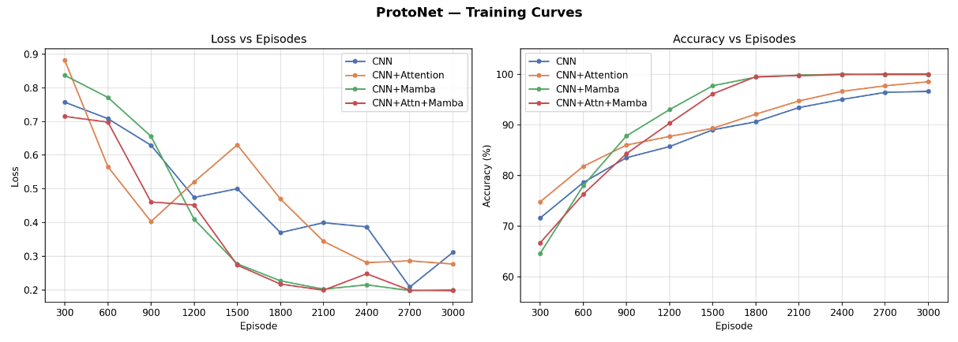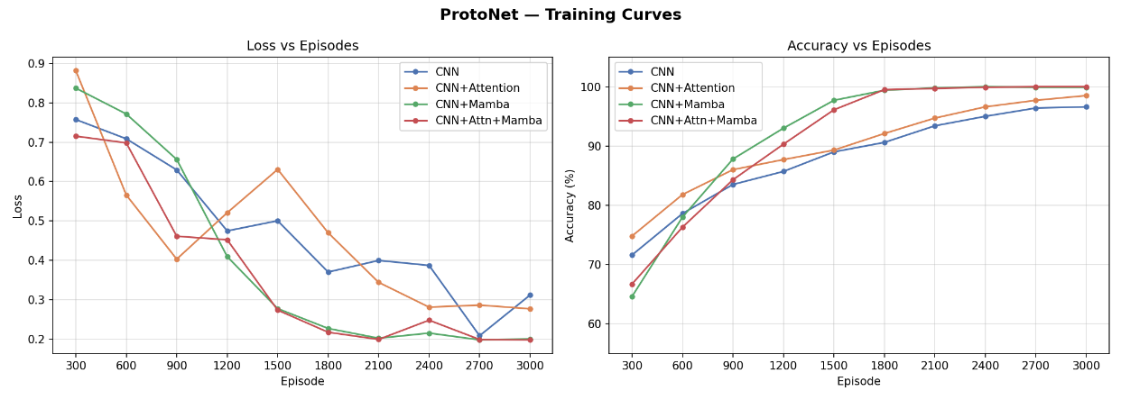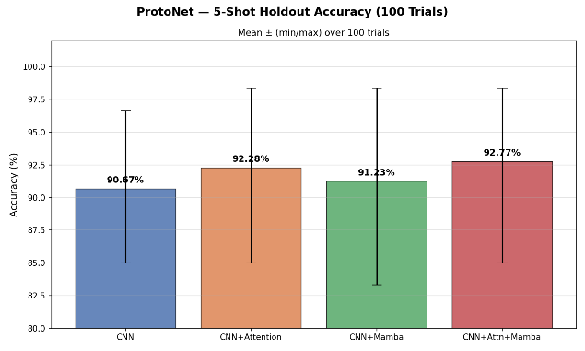

3 ) MAML
The MAML-based model showed lower overall performance compared to ProtoNet and RelationNet.
Although the CNN backbone allowed some learning, the model struggled to maintain stable generalization across trials. The lower median accuracy and wider spread indicate inconsistent adaptation performance in the few-shot setting.
This suggests that MAML may require stronger feature extractors or additional optimization strategies to compete with the hybrid ProtoNet and RelationNet architectures.
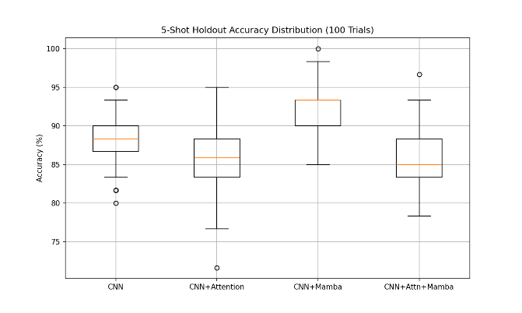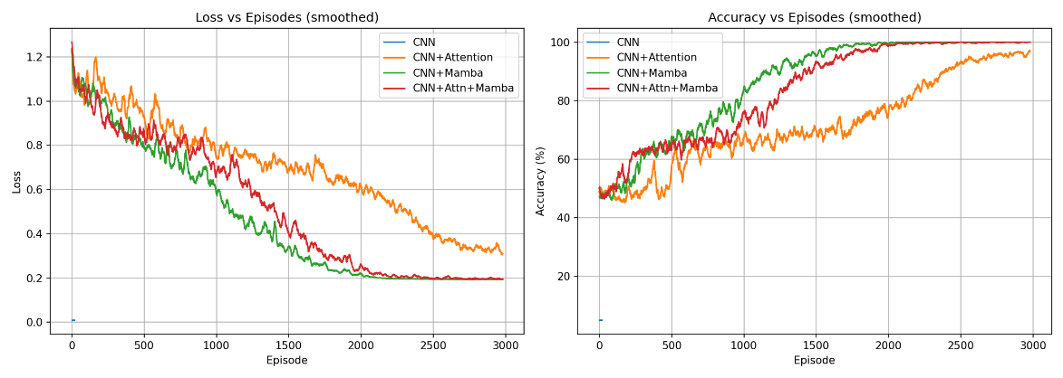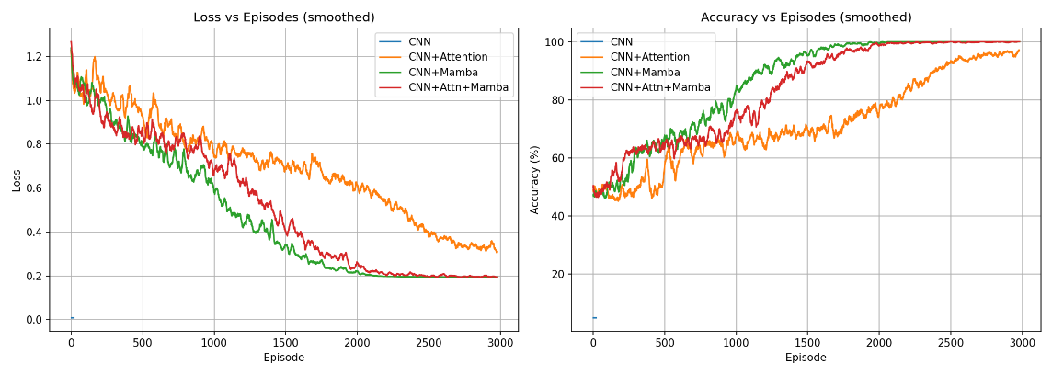
Conclusion
The ProtoNet with CNN+Mamba achieved the highest accuracy of 99.93%, showing that the Mamba block helped the model learn feature relationships very effectively. RelationNet with CNN+Mamba also performed extremely well with 99.79% accuracy, proving that combining CNN with Mamba improves classification performance.
The CNN+Attention versions also gave strong results, but slightly lower than the Mamba-based models. This suggests that attention mechanisms helped the model focus on important features, but Mamba provided better long-range feature understanding and stability.
MAML with only CNN achieved around 50% accuracy, which is much lower than the other methods. This indicates that the basic CNN backbone struggled to generalize effectively in the few-shot setting compared to the hybrid architectures.
